**Practical 10**

**Implementation of KNN Clustering on Jupyter Notebook using Python.**

import numpy as np

import matplotlib.pyplot as plt

import pandas as pd

import seaborn as sns

iris = sns.load_dataset('iris')

labels = iris.species.unique()

iris.head() **#Output : Fig.10.1**

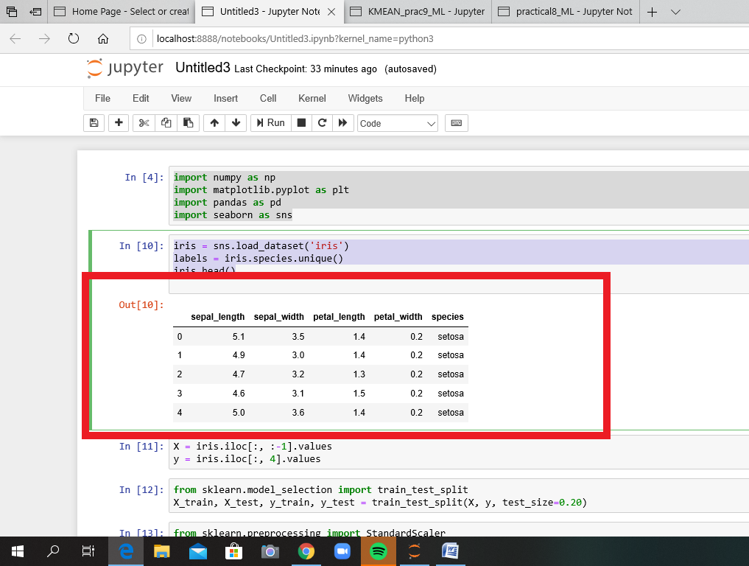

*Fig.10.1 iris.head()*

X = iris.iloc[:, :-1].values

y = iris.iloc[:, 4].values

from sklearn.model_selection import train_test_split

X_train, X_test, y_train, y_test = train_test_split(X, y, test_size=0.20)

from sklearn.preprocessing import StandardScaler

scaler = StandardScaler()

scaler.fit(X_train)

X_train = scaler.transform(X_train)

X_test = scaler.transform(X_test)

from sklearn.neighbors import KNeighborsClassifier

classifier = KNeighborsClassifier(n_neighbors=5)

classifier.fit(X_train, y_train) **#Output: Fig10.2**

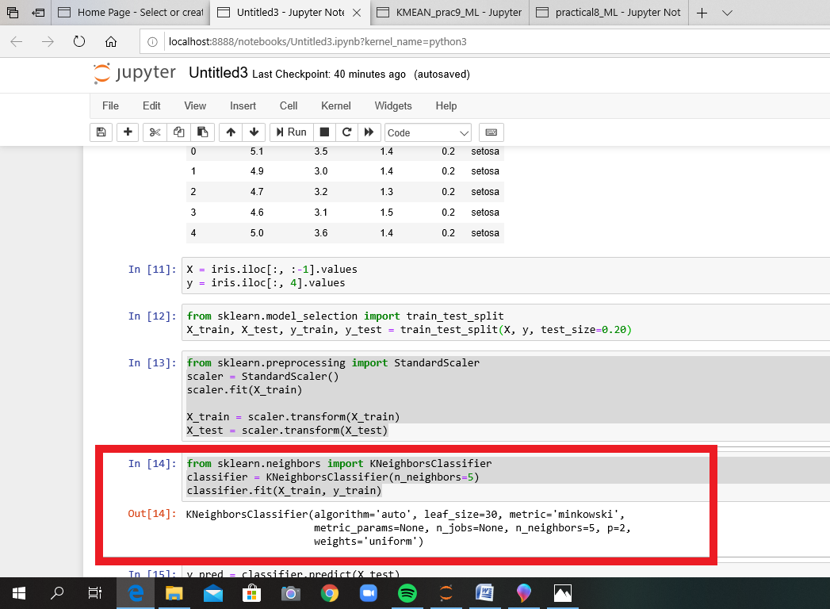

*Fig.10.2 KNeighbours Classifier*

y_pred = classifier.predict(X_test)

from sklearn.metrics import classification_report, confusion_matrix

print(confusion_matrix(y_test, y_pred))

print(classification_report(y_test, y_pred)) **#Output : Fig.10.3**

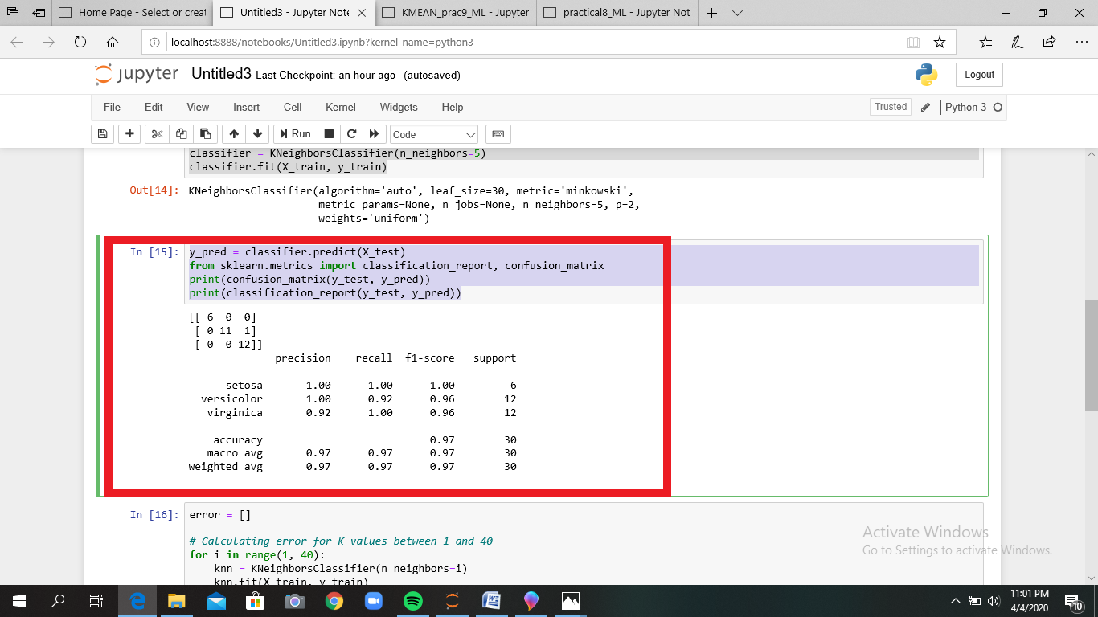

*Fig.10.3 Classification_report*

error = []

# Calculating error for K values between 1 and 40

for i in range(1, 40):

knn = KNeighborsClassifier(n_neighbors=i)

knn.fit(X_train, y_train)

pred_i = knn.predict(X_test)

error.append(np.mean(pred_i != y_test))

plt.figure(figsize=(12, 6))

plt.plot(range(1, 40), error, color='red', linestyle='dashed', marker='o',

markerfacecolor='blue', markersize=10)

plt.title('Error Rate K Value')

plt.xlabel('K Value')

plt.ylabel('Mean Error')

**Result Output :**

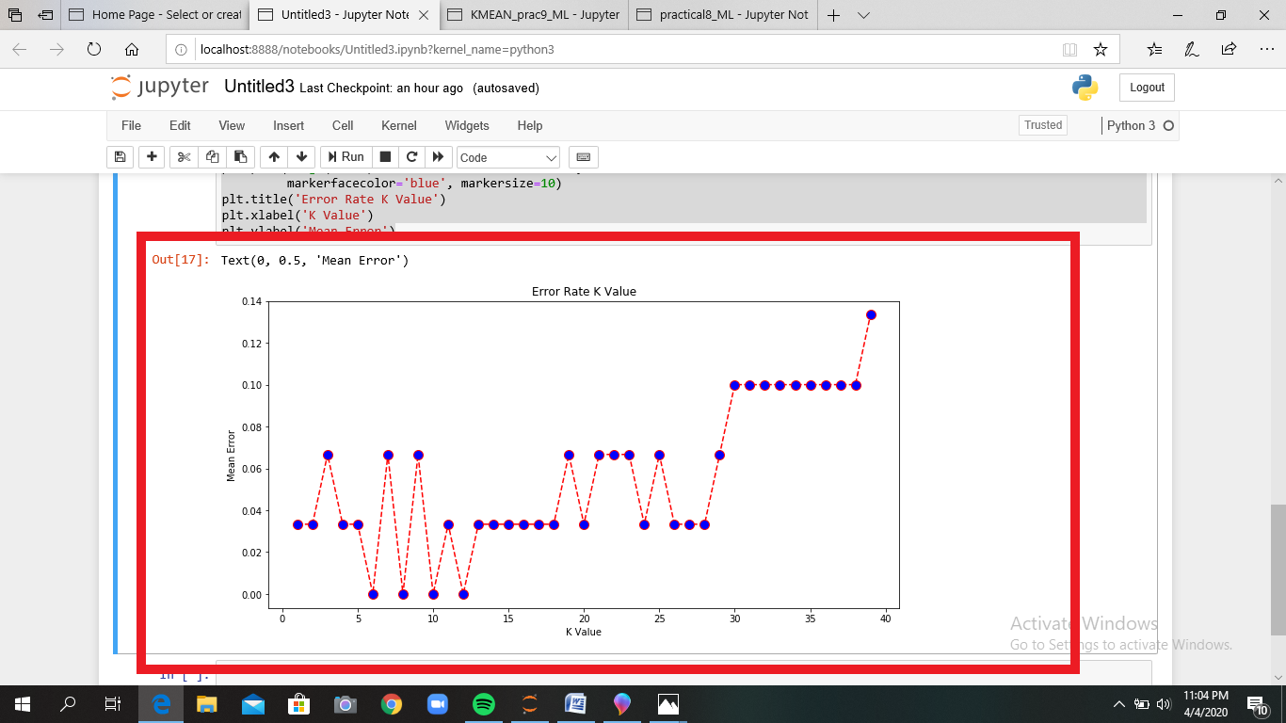

*Fig.10.4 Result Output(Error Rate)*